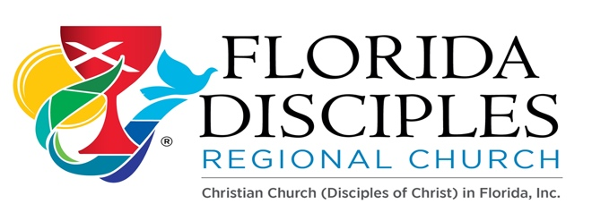

**Cómo Hacer: para los nuevos plantadores de iglesias y ministerios:**

**Políticas / Procedimientos:**

* Por favor lea las Pautas de la Comisión de Congregaciones Nuevas y Afiliadas <https://www.fldisciples.org/new-and-affiliating-congregations.html>

* Solicitar la propuesta de plantación de iglesias de becas regionales
* Mientras recibe fondos de la Región de FL, por favor entregue cada año el

Informe Anual del Plantador de Iglesias y solicitud de financiamiento al Consejo de Liderazgo

* Asistir a la reunión mensual de apoyo de los Nuevos Ministerios de la Región de Fl (2do martes de cada mes por zoom)

**Sunbiz / Incorporación sin fines de lucro:**

* Crear una junta básica (Presidente, Vicepresidente y Secretario, etc.) y tener el nombre y la tarjeta de crédito para pagar la tarifa.
* Encuentre y registre su nombre ficticio.

<https://www.dos.myflorida.com/sunbiz/start-business/efile/fl-fictitious-name-registration/>

**EIN:** As part of the Incorporation process the church needs an Employer Identification Number (EIN) provided by the IRS. Please go and apply for the EIN Online with the IRS at:

<https://www.irs.gov/businesses/small-businesses-self-employed/apply-for-an-employer-identification-number-ein-online>

**Start the church by creating a Non-Profit Corporation using:**

<https://www.dos.myflorida.com/sunbiz/start-business/>

**Every year file the Annual Report and pay the fee to update the corporation:** <https://services.sunbiz.org/Filings/AnnualReport/FilingStart>

**Letter of 501c3:** Once the FL Regional Leadership Council has accepted your new ministry as a congregation in formation or ministry, request a letter of 501c3 from the Regional Ministry.

**Open a bank account:** With all the prior documents you will be able to open a bank account under the name of the new church/ministry. Ask the bank for requirements, they may require a letter with the EIN, incorporation docs, 501c3 letter from FL Disciples Regional Church, etc.

**State Tax Exempt Certificate:** Apply for a FL state tax-exempt certificate. <https://floridarevenue.com/taxes/businesses/Pages/sales_cex.aspx>

**Expectations:**

* Attend the Leadership Academies from the General Church New Church Ministries with the team of your church: (Usually in September each year) <https://newchurchministry.org/>

<https://newchurchministry.org/services/leadership-academy/>

* 1. Start Track ($500 – Region/Transportation on their own)
  2. Sustain Track ($500 – Region and Congregation will pay half)
  3. Multiply ($700 – Region and Congregation will pay half)
* Leadership Council Representative: Attend to Leadership Council Quarterly to know what is happening in the Region or assign a church leader the responsibility to attend.
* Attend the FL Region New Ministries monthly Zoom support meeting (2nd Tuesday of each month).
* E-Glimpse: Read the E-Glimpse every other week to be informed of the Regional events and other groups' activities and/or training. Encourage participation among your church members.
* Giving form: Educate yourself and your congregation on how to give to the different disciples’ ministries and begin a faithful path of giving at the level you are able:

<https://cdn.disciplesmissionfund.org/wp-content/uploads/2017/12/23191000/Remittance-Form-English-2017.pdf>

* ALEX: Fill out the directory of the disciples as a congregation in formation: Go to…

<https://alex.disciples.org/>

Important Links for your use:

* Church Extension: Building Loans <https://disciplescef.org/>
* Pension Fund: <https://pensionfund.org/>
* Week of Compassion: <https://www.weekofcompassion.org/>
* National Benevolent Association of the CCDOC: Training for New Ministries

<https://www.nbacares.org/>

Other References:

<https://disciples.org/>

<https://www.fldisciples.org/index.html>

Letter of Call: Fill out a letter of call with your congregation which can be updated annually.

(Please see next page…)

