New & Affiliating Congregations Commission

Year 2020 | Guidelines for the Florida Regional Church
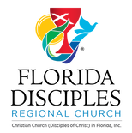
This document serves to discuss the best practices of the New & Affiliating Congregations Commission in the establishment of new congregations and the adoption of congregations through the affiliation process.

New & Affiliating Congregations Commission
Guidelines for the Florida Regional Church

The Regional team |New church MINISTRY
The New & Affiliating Congregations Commission Regional Team for the Florida Region assumes the role of “partner” in the new church planting process. As partners, a good regional team will involve persons who have a love for and an understanding of evangelism/mission field, human community, prayer, communication, organizational skills, acceptance, and an encouraging outlook.
As the new church planter develops the ministry, the regional team comes alongside to support and nurture the new thing in formation. This means that the team assures that its practices are geared toward ensuring that the project has what it needs to succeed.
I planted the seed, Apollos watered the plants, but God made you grow. It’s not the one who plants or the one who waters who is at the center of this process but God, who makes things grow. Planting and watering are menial servant jobs at minimum wages. What makes them worth doing is the God we are serving. You happen to be God’s field in which we are working. 1Corinthians 3:6 (MSG)
The team will consist of five to seven (5-7) persons, with work being divided in the following suggested ways:
- Chairperson: The chair will coordinate meetings, communicate with team members, receive and process planter financial proposals, delegate tasks and/or assign liaisons to the diverse church plant projects that are active across the Region, in conjunction with the Regional Minister. Chair will also facilitate the process of collaboration (see Synergy) between regional and general ministry partners. Reporting before the Regional Church will also be necessitated at each Administrative Team and Leadership Council gatherings throughout the year.
- Meeting Recorder: The team will assure that all meetings are recorded and all members receive copy of the same in a timely manner. The Recorder can be assigned within the team members at each meeting.
- New plant project Liaisons: team members are assigned to one new church plant project to nurture the relationship with the planter. This liaison would also commit to visiting (or connect with) the church, continually pray for the church and planter, and help seek out churches that have surplus supplies that could be utilized by the plant. Project liaisons will be assigned by the Chairperson and report back to the team regularly.
- Affiliate Liaisons: Team members can also be assigned to one church that is affiliating with the Christian Church (Disciples of Christ). This liaison, assigned by the Chairperson, will commit to offer hospitality to the affiliating congregation, assisting the pastor(s) in the life of the Christian Church (Disciples of Christ) and the Regional Church. Hospitality will consist of intentionally working to grow together in relationship and pray for the new partnership. (see Affiliating Congregations section for further information). This process can be agreed among liaison and affiliate, including a date of termination.

Suggested actions are: establish quarterly phone calls to touch base, pray for special concerns, and assist in navigating through the various ministries and services of the Christian Church (Disciples of Christ).
In general, affiliating congregations are transitional, which means that they ultimately desire to fully become a Christian Church (Disciples of Christ). Should this be the case, the affiliate liaison will work closely with the congregation, the Chairperson, and the Regional Minister to set a timeframe to complete the process of full recognition. [This process is further discussed under Affiliation].
Some affiliating congregations are dual, meaning that the congregation wishes to retain prior denominational recognition, along with the Christian Church (DOC) designation.

Length of service: Persons serving on the N&ACC team will be asked to serve from three to four years.
Accountability: The N&ACC is accountable to the Administrative Team (herein referred to as the “Admin Team”) and the Leadership Council of the Regional Church. The chairperson (or a representative of the team in the absence of the Chairperson) will attend the quarterly Admin. Team meetings and submit a written report at the semi-annual Leadership Council gatherings. The N&ACC will recommend and submit for approval any funds for the church plant projects, firstly to the Admin. Team, and then to the Leadership Council for final approval.
Frequency of meeting times: The N&ACC will meet three to four (3-4) times per year.

Synergy between Planter, Region, and General New Church Partners.
While we assume the role of partner, there is a healthy practice of assessing the planter and checking motivations for the project. Communication, credentialing, and cooperation are vital and healthy practices for the project’s success. Below is a project flow chart, as suggested by the General New Church Ministry Best Practices (p. 32), which reflects the desired synergy between all partners:
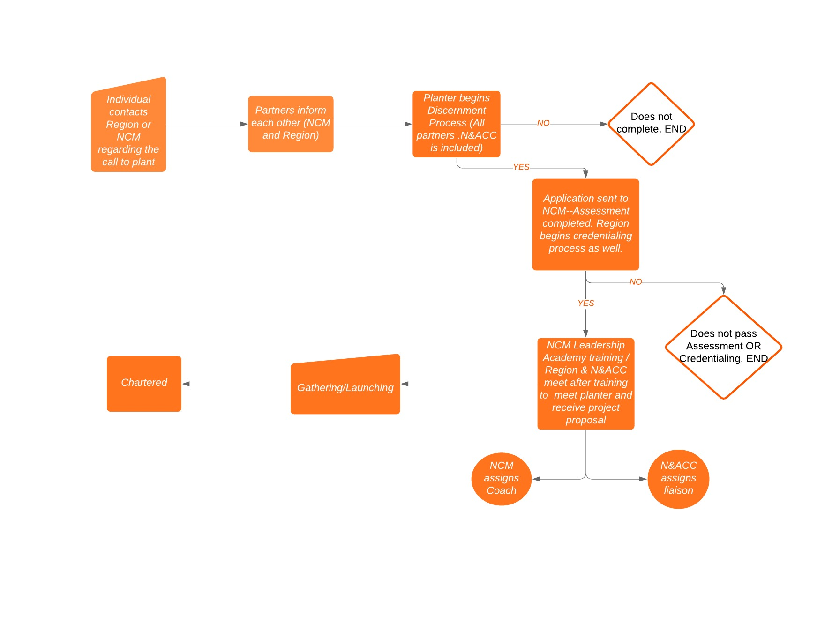
Following is a summary of the synergy between all partners:
Initial Contact and Discernment:
The prospective planter contacts the Regional Church or the New Church Ministries of the General Church regarding her/his desire to plant a ministry. The regional and general partners inform each other of this prospect and each begins to assist the planter in the discernment process. As per New Church Ministries, the 30-day discernment involves prayer, scripture reading and self-reflection on the call of church planting. This guide may be accessed online: https://newchurchministry.org/resources/spiritual-discernment/ . At the end of this process, the prospective church planter is encouraged to contact the Regional Minister for next steps or additional conversation.
Application:
If discernment leads to further potential, then the process continues with application via the various partners:
- New Church Ministries (NCM) will begin its own assessment and screening process
- The Region begins its credentialing process through the Commission on Ministry (COM) and the New & Affiliating Churches Commission (N&ACC). Best practices will inform other general and/or regional partners related to the church plant (i.e. Obra Hispana/SE Hispanic Convención, NAPAD, National/Regional Convocation, or Haitian Ministries).
- The N&ACC’s screening process involves meeting personally with the prospective church planter after requesting the submittal of a preliminary church planting proposal (see Church Planter Proposal - Appendix A).
Training:
If these processes reveal further potentiality and relationship, then the planter can begin the NCM planter training known as Leadership Academy. The Region can sponsor this training on the condition that there are funds available.
Launching:
If the planting project is recognized by the Region, then NCM will assign the planter with a coach who will accompany her/him for the first year of launching the church plant. Launching phase or process begins from the point of visioning through the beginning of worship services.
N&ACC will also assign a liaison and issue financial assistance. [NO funds will be given to planter before Leadership Academy training and regional recognition, AND an updated Church Planter Proposal-Appendix A is submitted].
In Launching, the planting project is presented before the Region’s Leadership Council to be recognized as a new church start, and designated in the Yearbook with an “F” status for “Congregation-in-Formation”. This designation assumes that the planter is actively engaged in the field and is already gathering a faith community.*** Once the project has been approved by the Leadership Council, the planter will be responsible for the legal process of establishing the congregation as a non-profit organization, under the guidance of the Regional Minister and/or N&ACC (i.e. Articles of Incorporation on Sunbiz.org, State of Florida tax exempt status/certificate, etc.). Copies of these Articles and tax-exempt documentation need to be submitted annually.
Chartered:
This status is granted to a congregation once it is fully recognized as a congregation by the Region and is considered a self-sufficient, viable/sustainable congregation. (Congregation and Region together will discuss conditions to obtain this final designation).

Years “Under Care”.
While New Church Ministries appoints a coach for the first year (planter has the option to continue the coaching relationship but with personal funding), the N&ACC relationship “under care” will remain for the period that the church planter is “under care” by the Commission of Ministry.

Sustainability.

New churches are supported through the Pentecost Offering and other donations to the Florida Region by Disciple churches and/or individuals. Therefore, sustainability will depend on the availability of these funds. Below are the suggested guidelines for financial support to the church planter:

Sustainability will be for the first three years beginning at launch, with potentially an additional two years thereafter:

At launch: $ 5,000

Year 1 Launch anniversary: $10,000

Year 2: $10,000
*Planter shall receive no more than $10,000 per calendar year. Funds will be subject to Planter submitting a yearly report on the project. (see Church Planter Report – Appendix B). Requests for funding before the N&ACC should be submitted three months prior to the Leadership Council meetings to provide ample time for review.

Benchmarks.
The new church plant will remain under the support of the N&ACC for five or more years, pending on a healthy, communicative relationship. The following benchmarks can help assess the relationship going forward:
- Church planter submits annually the Church Planter Report (see Appendix B). Report reviews will take place by the N&ACC in its predetermined meetings.
- Connections between liaison and planter are regularly kept and an annual meeting with the N&ACC is held, via in person or through a social online platform.
- Church planter maintains involvement with the Regional church events and/or gatherings.
- Church planter continues his/her own leadership development and coaching relationship with New Church Ministries (Note: coaching is only for the first year. Planter has the option to request a second year, but it will be at his/her own expense).

Congregationally Initiated Planting Projects.

While the majority of new church planting projects are initiated by individuals, there have been instances where an existing congregation receives the calling, or is challenged to consider commissioning a servant planter or planting a new congregation.
Now in the church at Antioch there were prophets and teachers: Barnabas, Simeon called Niger, Lucius of Cyrene, Manaen (who had been brought up with Herod the tetrarch) and Saul. While they were worshiping the Lord and fasting, the Holy Spirit said, “Set apart for me Barnabas and Saul for the work to which I have called them.” So, after they had fasted and prayed, they placed their hands on them and sent them off. Acts 13:1-3 (NIV)

Both the Regional Minister and New Church Ministry collaborate to steer the process for the existing congregation, which will include, but will not be limited to, the development of the ministry plan and a planter profile. Once an assessed planter is affirmed, the process of developing the congregation will begin as a normal church start. The procedures delineated above for individual projects can be used or adapted for these purposes by the N&ACC.

The Regional team |affiliatING cONgregations
Receiving a church community seeking the covering of a denomination with values similar to theirs is the work of the affiliation process by the Region. While the process may differ depending on particular circumstances and contexts, the goal of these guidelines is to offer a more common process of adopting new congregations.
As suggested by the Best Practices for Establishing Vital Congregations (p. 34), it is important to keep the following principles in mind:
- Affiliation is a process for both the congregation seeking adoption as well as the Region. It is not about making a congregation demonstrate its worthiness, but a conversation about our desire to associate together for the Disciple witness.
- Affiliation is not a bureaucratic process where the congregation applies and waits for the parenting church to accept them. It is a relational process where both parties seek to understand each other and clarify their meaning about being Disciples.
- Assure that the dual processes run parallel: that of the credentialing process for the pastor and the affiliation process of the congregation. Both should be timed together so they reach completion simultaneously.
- Affiliation is a process for the whole church, not singly the region. While the region has the responsibility for this process, racial ethnic pastors and NCM can be helpful partners in the process, especially where language and cultural skills are necessary for understanding.

Hence, the affiliation process will involve two processes:
- The credentialing process of the pastor and
- The affiliation process of the congregation.
The Regional Minister and the N&ACC will meet with the congregational leadership along with pastor(s), and submit to them the Formal Request for Affiliation (Appendix C). Appendix C is the official document to hand out to congregations seeking affiliation with the Christian Church (Disciples of Christ).

Phases of Discernment for Affiliation.

The following process is intended to lead both the congregation requesting affiliation and the Florida Region to discern if they should enter into covenantal relationship. Herein the requesting congregation is identified as the “Congregation in Process” (CIP).

Initial Phase:

The CIP (which includes its board and pastor(s)) meet with the Regional Minister

The CIP sends a notarized letter to the Florida Regional Church’s Leadership Council stating the official desire of the CIP to seek affiliation. [A copy of this letter will go to the CIP’s current denomination, if the CIP is in relationship with a denomination].

The CIP will complete the formal request form for affiliation, “Affiliation Discernment Process Request” (See Appendix C under “Discernment Process”).

The CIP will present document(s) verifying that it is a not-for-profit organization

The CIP will meet with the N&ACC.

Study Phase.

The Florida Regional Church (through the Regional Minister and its Administrative Team) leads the CIP in the study of the history and polity of the Christian Church (Disciples of Christ) in the United States and Canada.

Theological compatibility will be assessed by discussing themes such as: the centrality of Jesus Christ – The Good Confession; The Preamble to The Design of the Christian Church (Disciples of Christ); the core values of “covenant” and “ecumenism”, and an appreciation for the theological diversity within the Christian Church (Disciples of Christ).

Mutual expectations between the CIP and the Florida Region will be explored.

Decision-Making Phase:

A “process for deciding” is agreed upon between the CIP and the Florida Region indicating the percentage of the congregational vote required to affiliate.

The CIP votes on entering into covenant relationship with the Florida Region, as indicated in The Design of the Christian Church (Disciples of Christ) in the United States and Canada. It then will notify its decision to the Florida Region.

The Region’s Leadership Council grants the CIP a “Congregation in Formation” (CIF) status and is listed in the Yearbook and Directory of the Christian Church (Disciples of Christ).

Nurturing and Commitments Phase.

The N&ACC will assign an affiliated liaison (see N&ACC Team page 1).

If the CIP owns real estate property, its Title and Non-Profit status are reviewed.

The congregation’s Constitution and By-Laws are amended as necessary.

Articles of Incorporation are submitted.

A “Mission Statement” consistent with the affirmations of the “Preamble” to The Design of the Christian Church (Disciples of Christ) is adopted by the CIF.

The congregation prayerfully and financially supports the work of the General Church and seeks to grow toward a tithe to the Disciples Mission Fund.

The congregation’s pastor(s) seek(s) recognition as a minister with the Florida Regional Church.

The congregation discloses to the Florida Regional Church its financial situation.

The congregation commits to participate in the life and ministry of the Florida Regional Church.

Recognition and Covenanting Phase.

The congregation’s leadership will meet with the Florida Regional Church’s Administrative Team. Together they sign the “Covenantal Affirmations for Affiliating Congregations” document (last page in Appendix C) and present before the Leadership Council.

The Leadership Council votes to receive the CIP as a “Recognized Congregation”. [The CIP Year Book status is also changed from “Congregation in Formation” to “Recognized Congregation.”]

A date is set for a service of “Covenanting and Celebration.”

The congregation is officially recognized at the next Regional Church Assembly.

These guidelines have been adapted, in part, from the General Office for New Church Ministries.

